Notes
- Lots of irrigation/discharge data
  - Long one- https://pubs.usgs.gov/publication/wsp177
- Some groundwater
  - https://pubs.usgs.gov/publication/wsp213
- Lots of “water resource” and “water supply/storage”
  - “Storage of water on Kings River, California”
  - “Storage reservoirs on Stony Creek, California”
  - “Water resources”- https://pubs.usgs.gov/publication/wsp298 - Includes river discharge and gage measurements

Examples
Irrigation near Bakersfield, California
https://pubs.usgs.gov/publication/wsp17

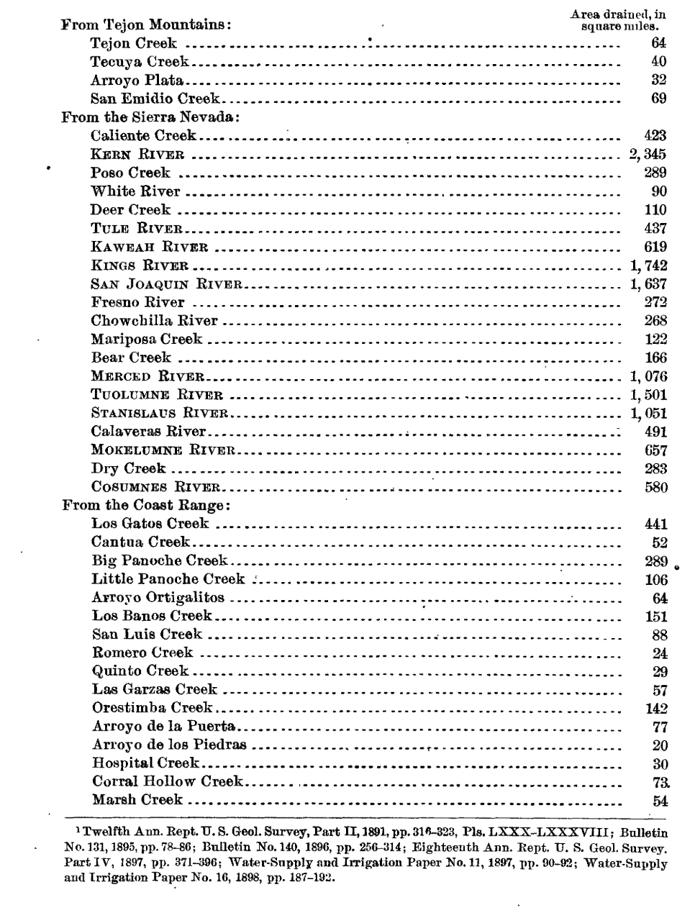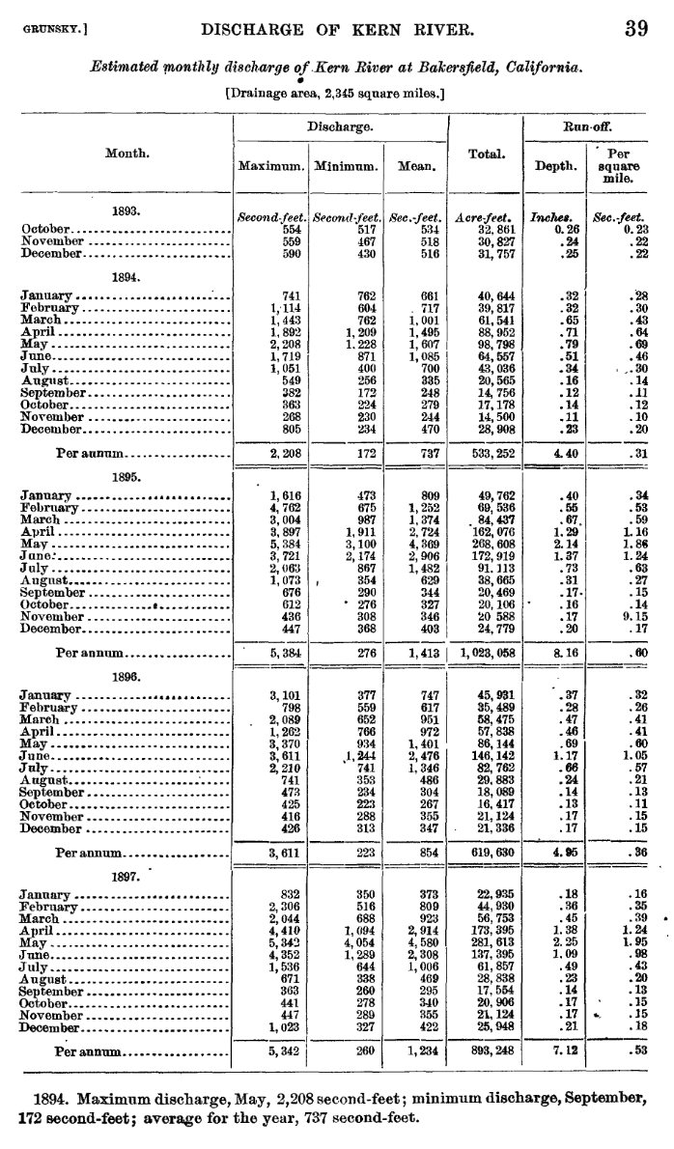
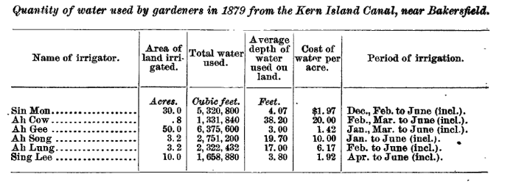

Irrigation near Merced, California
https://pubs.usgs.gov/publication/wsp19
Both by Carl Ewald Grunsky
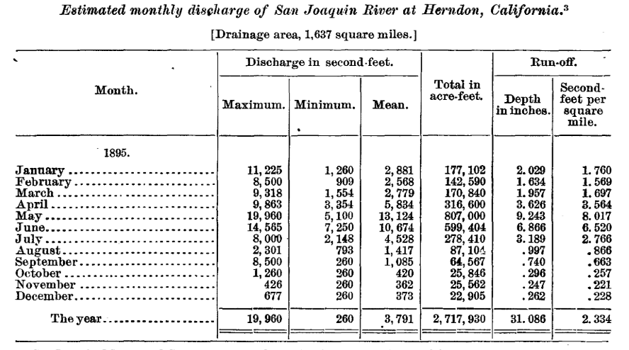
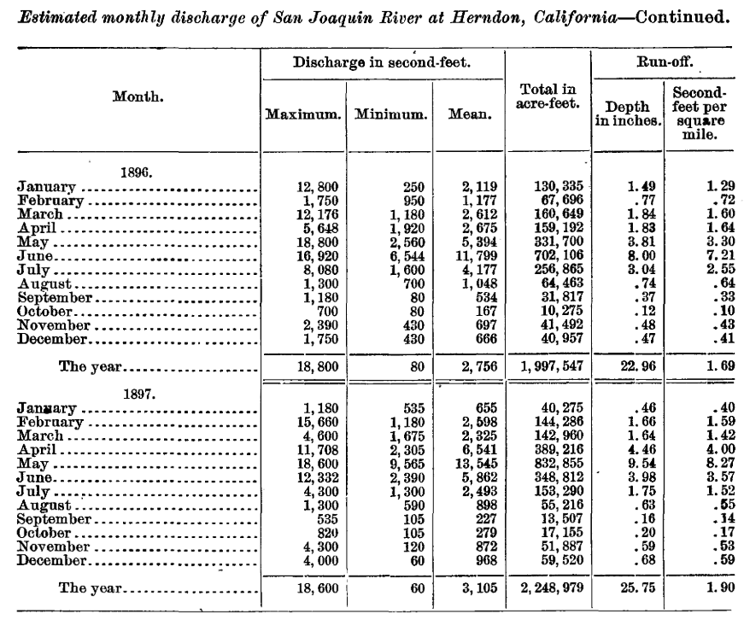
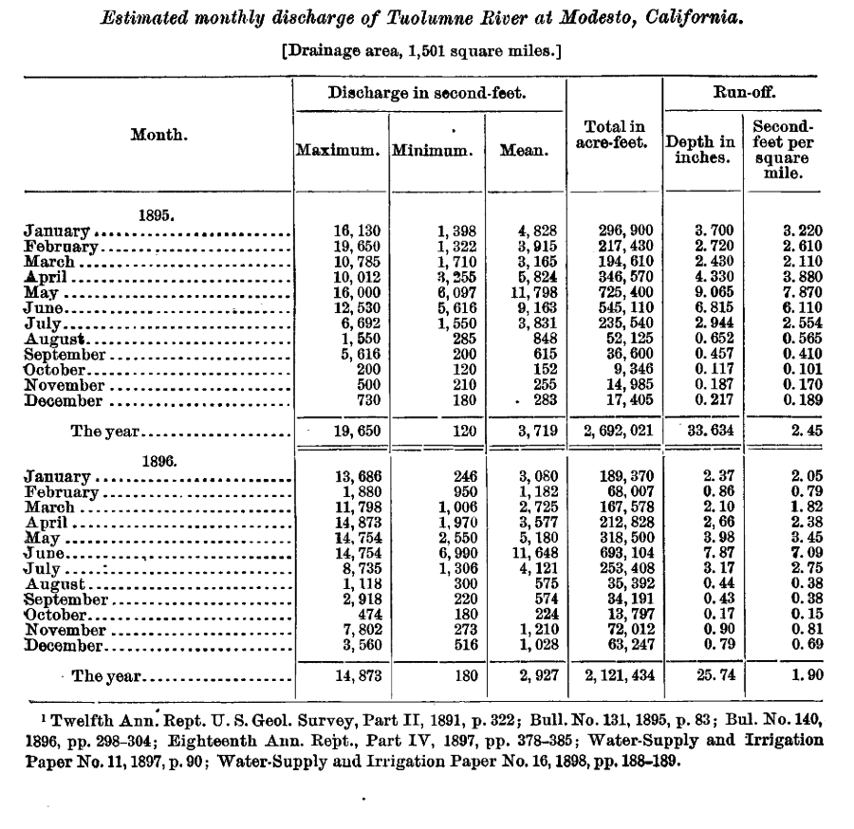

Physical characteristics of Kern River, California and Reconnaissance of Yuba River, California
https://pubs.usgs.gov/publication/wsp46

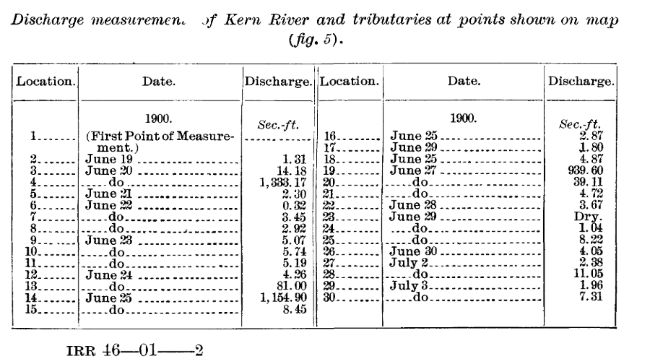
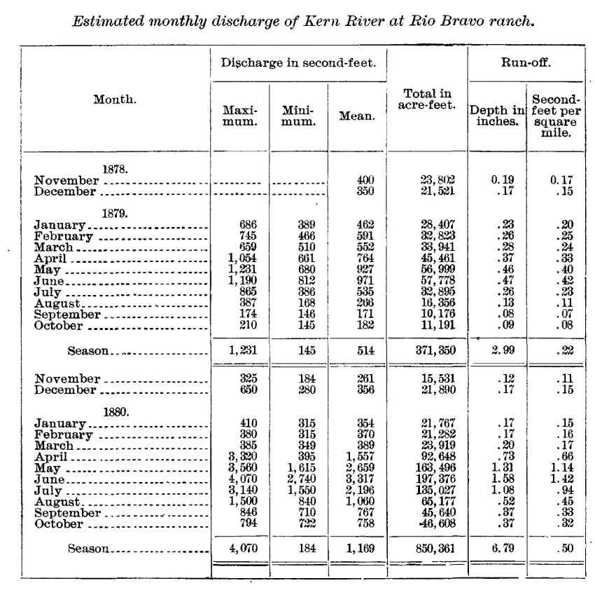
Lots more tables of Kern River discharge

The surface water supply of California, 1906, with a section on ground-water levels in southern California (Great Basin and Pacific Ocean drainages in California and lower Colorado River drainage)
https://pubs.usgs.gov/publication/wsp213
